**Project Setup**

**Silangquan**

**2014.12.19**

**Directory Specification**

Assets – Store all art, animation and sound assets in their raw, naked form.

Source – Source code, solution file and makefile.

Temp – Store intermediate files of compilation.

Docs – A reference for the development. Store both document and technical specifications.

Game – Executives and demo.

Test – hold special files only for testing. Including test scripts/test utilities/log file. Release notes.

Lib – Build target.

When you want to show someone about your engine. You just need files in Game directory. The test group grabs Game and Test, and they have everything they need.

**Environment**

**Hardware**

CPU: I7-3770

RAM: 8GB

GPU: GTX 680 Driver:340.52

**Software**

Qt5.3.2 msvc2013_64_opengl

VS2013

Visual assistant X 10.9.2048.0

**Construct project under Visual Studio 2013**

1. Create an project in Qt Creator.

Choose vs compiler 12 as default compiler.

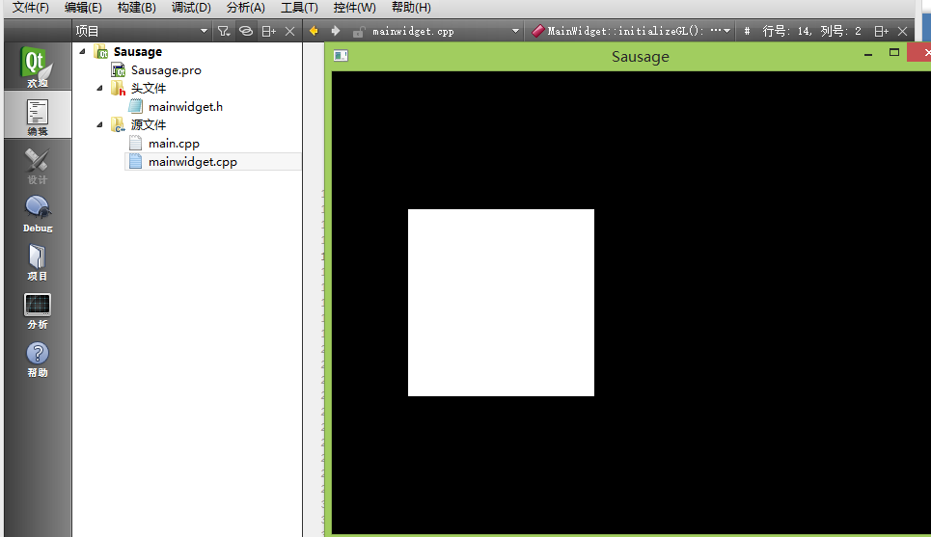

1. Load project into VS2013.
2. Show console when run program.

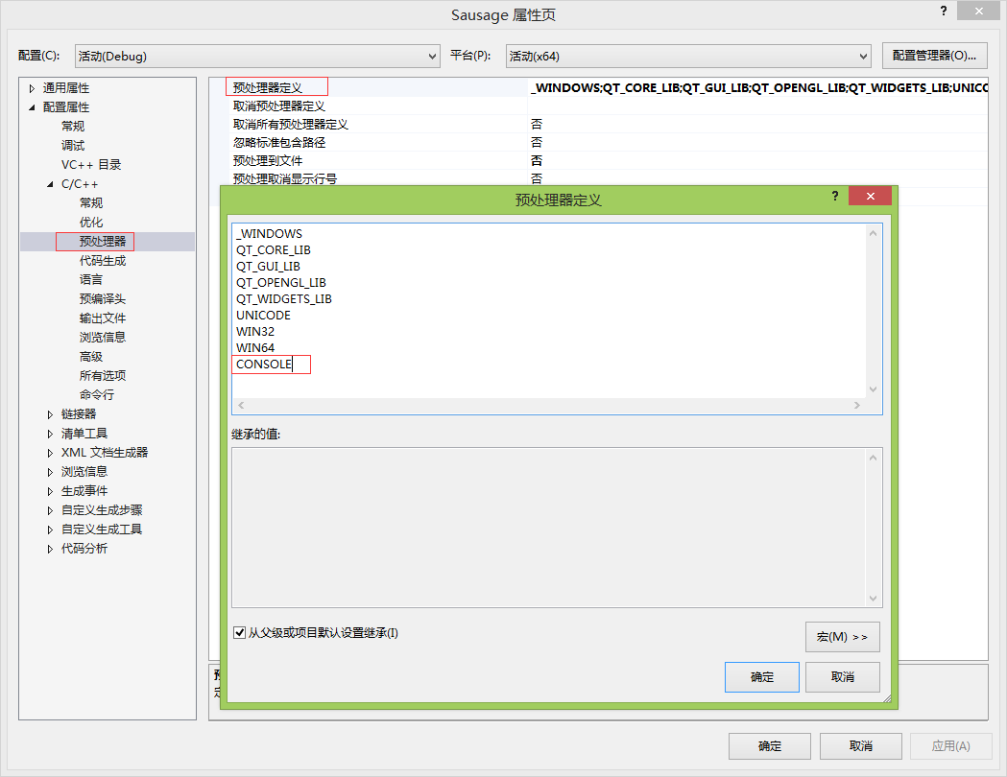

1. Change build destination to Temp Directory.

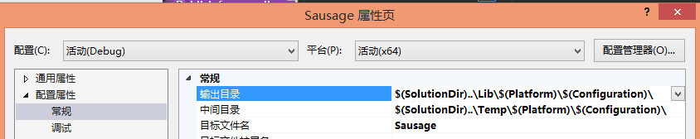

1. Show console while run application.

Project Properties > Linker > System : set SubSystem to "SUBSYSTEM:CONSOLE"

1. Compile and run.

